# Current Activities

3279 Colour Terminal

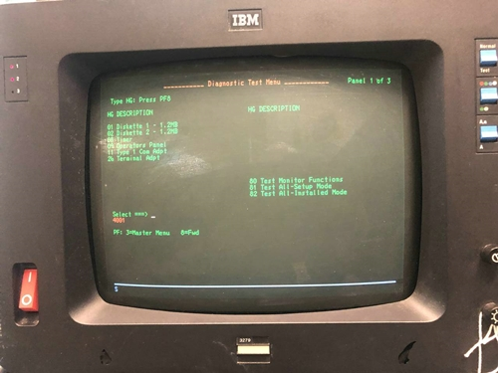We now have a working 3279 colour display terminal running diagnostics from a working 3174 controller. We weren’t able to get the machine working that was reported last time. The power supply checked out OK, but the analogue card is U/S. We have neither replacement nor circuit diagrams.

We retrieved the 110 volt machine from storage and with a bit of effort persuaded it into life. It is a completely different design internally, and appears to have been a development model.

3174 Controller

The 3174 was in good health, and after some reading to determine how to boot it up to run diagnostics we connected it via co-ax cable and this is the result.

3278 Mono Terminal

The 3278 mono terminal has also been tested on the controller. It does now show most of the diagnostics screen, but is very faint and very jittery. This still suggests analogue card, and we’ll need to see if the brightness can be boosted. Otherwise it will need to remain as a static display.

129 Card Punch / Verifier

The 129 card punch / verifier is about ready for its first power up, and has been cleaned to a level where we can put it out on display, and lubricated. Whilst it does now power up to the extent that the motor runs, the machine currently does not otherwise function. Initial measurements around the power supply reveal some out of specification voltages.

Schools Computer

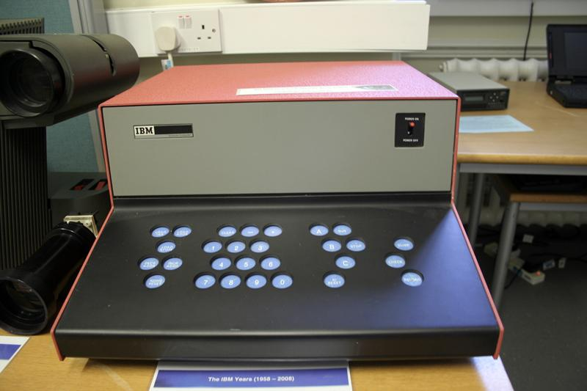We’ve been contacted by an employee interested in the 1969 Schools Computer project. He is planning to build a working replica, possibly half size and with modern screen. We’ve supplied copies of documentation we have in the archive, and facilitated a visit to Oxford University Science Library, where there is further documentation he can scan. If he succeeds with the replica he will make a second one for the museum. Our machine that is on display is an empty shell, nothing inside.

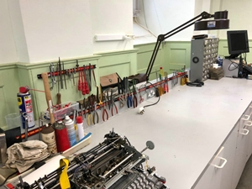

Back Office

A long overdue tidying up of the back office workbench has finally happened. The old CE tool case contents are now hanging from magnetic strips, thus saving quite a bit of workspace.

System/390

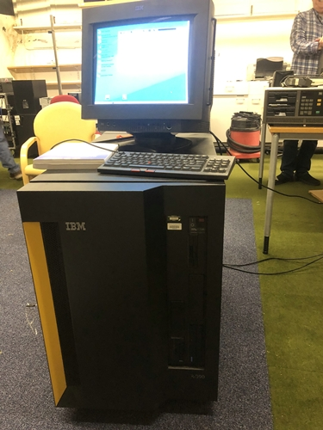Our recently acquired System/390 including the integrated Support Console which runs a tailored version of OS/2 has been successfully powered up. We now need to work out how to get the actual S/390 to do something useful.

The cooling fans are extremely noisy so we might need to find a small room in which to run demos without disturbing the whole museum! Or maybe we can find some suitable quiet-running fans for it, or some noise cancelling headsets...

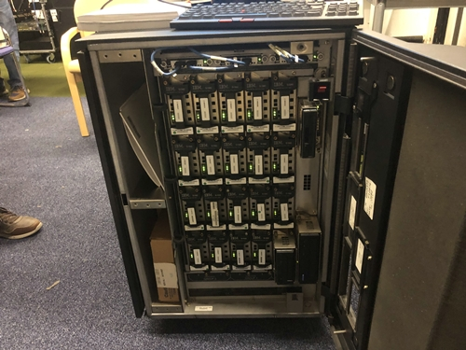

This S/390 is part of the family of Multiprise servers IBM announced in the late 90s. Its prime purpose was to provide a companywide server for Small and medium enterprises, as such these machines became very popular and were adopted by many smaller corporations across the world.

Museum Websites

Christmas week saw a big increase in site visitors. The museum website saw over 3000 page views during the week, the photo archive over 500.